TRANSNATIONAL PROJECT MEETING REPORT
“Beyond the Limits: Developing Entrepreneurship via Creativity in Schools” (GRANT_NUMBER: 2020-1-TR01-KA203-093989)
Date: 3 to 5 July 2023
Place: Faculty of Psychology and Education Sciences, University of Coimbra

PROGRAMME
2.7.2023 | 16.00-19.00 | Welcome Meeting and Introduction to the Faculty
3.7.2023 | 10:00-10:30 | Welcoming (Palacete Sacadura Botte – BL Headquarters)
 | 10:30-12:30 | Project coordination – Curriculum development (Meeting 1)
 | 12:30-14:30 | Free lunch
 | 15:00-16:00 | Project coordination – Joint report (Palacete Sacadura Botte) (Meeting 2)
4.7.2023 | 10:00-11:00 | Project coordination – E-Book (Palacete Sacadura Botte) (Meeting 3)
 | 11:00-11:30 | Coffee break
 | 11:30-12:30 | Coordination of presentations on the Entrepreneurship and Creativity Needs Analyses (Meeting 4)
 | 12:30-14:30 | Free Lunch
 | 15:00-17:00 | Visiting Jardim Botânico and Seminário Maior
5.7.2023 | 10:00-11:00 | Project coordination – E-Book (Palacete Sacadura Botte) (Meeting 5)
 | 11:00-11:30 | Coffee break
 | 11:30-12:30 | Visiting ICLEL2023 Rooms – preparing the multiplier event (FPCEUC)
 | 12:30-14:00 | Free Lunch
 | 15:00-17:00 | E- Book Publication Issues
9.7.2022 | 9.00-11.00 | General Evaluation of the Week -Virtual
TRANSNATIONAL PROJECT MEETING PARTICIPANTS
“Beyond the Limits: Developing Entrepreneurship via Creativity in Schools” (GRANT_NUMBER: 2020-1-TR01-KA203-093989)
NAME | UNIVERSITY | COUNTRY | MEETING
Felix Angel Popescu | Agora University of Oradea | Romania | X
Dan Petrica | Agora University of Oradea | Romania | X
Laurentiu Petrila | Agora University of Oradea | Romania | X
Giovanni Crisona | Centro Studi Cultura Sviluppo Associazione | Italy | X
Osman Titrek | University of Sakarya | Turkey | X
Ömer Faruk Vural | University of Sakarya | Turkey | X
Mustafa Bayrackci | University of Sakarya | Turkey
David Rae | De Monfort University | United Kingdom | X
Regina Frank | De Monfort University | United Kingdom | X
Michele Biasuti | University of Padua | Italy | –
Eleonora Concina | University of Padua | Italy | –
Sara Frate | University of Padua | Italy | –
Pablo García Sempere | University of Granada | Spain | X
José Gijón Puerta | University of Granada | Spain | –
Linda Pavitola | University of Liepaja | Latvia | –
Ilze Mikelsone | University of Liepaja | Latvia | X
Jana Grava | University of Liepaja | Latvia | X
Carlos F. de Sousa Reis | University of Coimbra | Portugal | X
Albertina Lima Oliveira | University of Coimbra | Portugal | X

EU Beyond the Limits: Developing Entrepreneurship via Creativity in Schools” (GRANT_NUMBER: 2020-1-TR01-KA203-093989 project Transnational Project Meetings held on University of Coimbra, Faculty of Physcology and Educational Sciences between 2-8 July 2023. During these period we conducted

No one from Italy participated in the face-to-face meetings at the transnational project meeting held at the University of Coimbra between July 2-5, 2023. Also, Prof.Dr. Linda Pavitola from Latvia team could not attend due to illness. Padova University-Italy team and Prof.Dr. Linda Pavitola attended the meeting virtually via Google Meet. The photos of the project meeting are given below. Sunday afternoon (2 July 2023) we met in University Coimbra and we visited to places we will conduct project activities and we made a discussion about the project during this meeting.

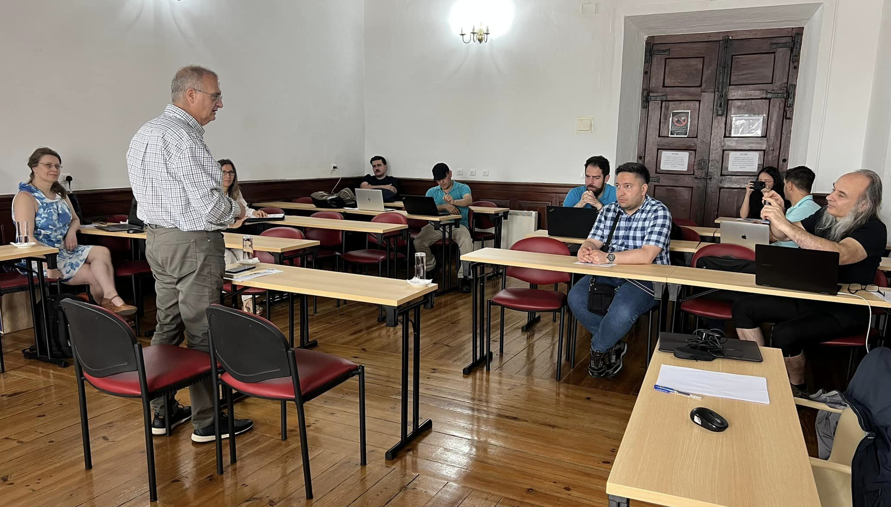

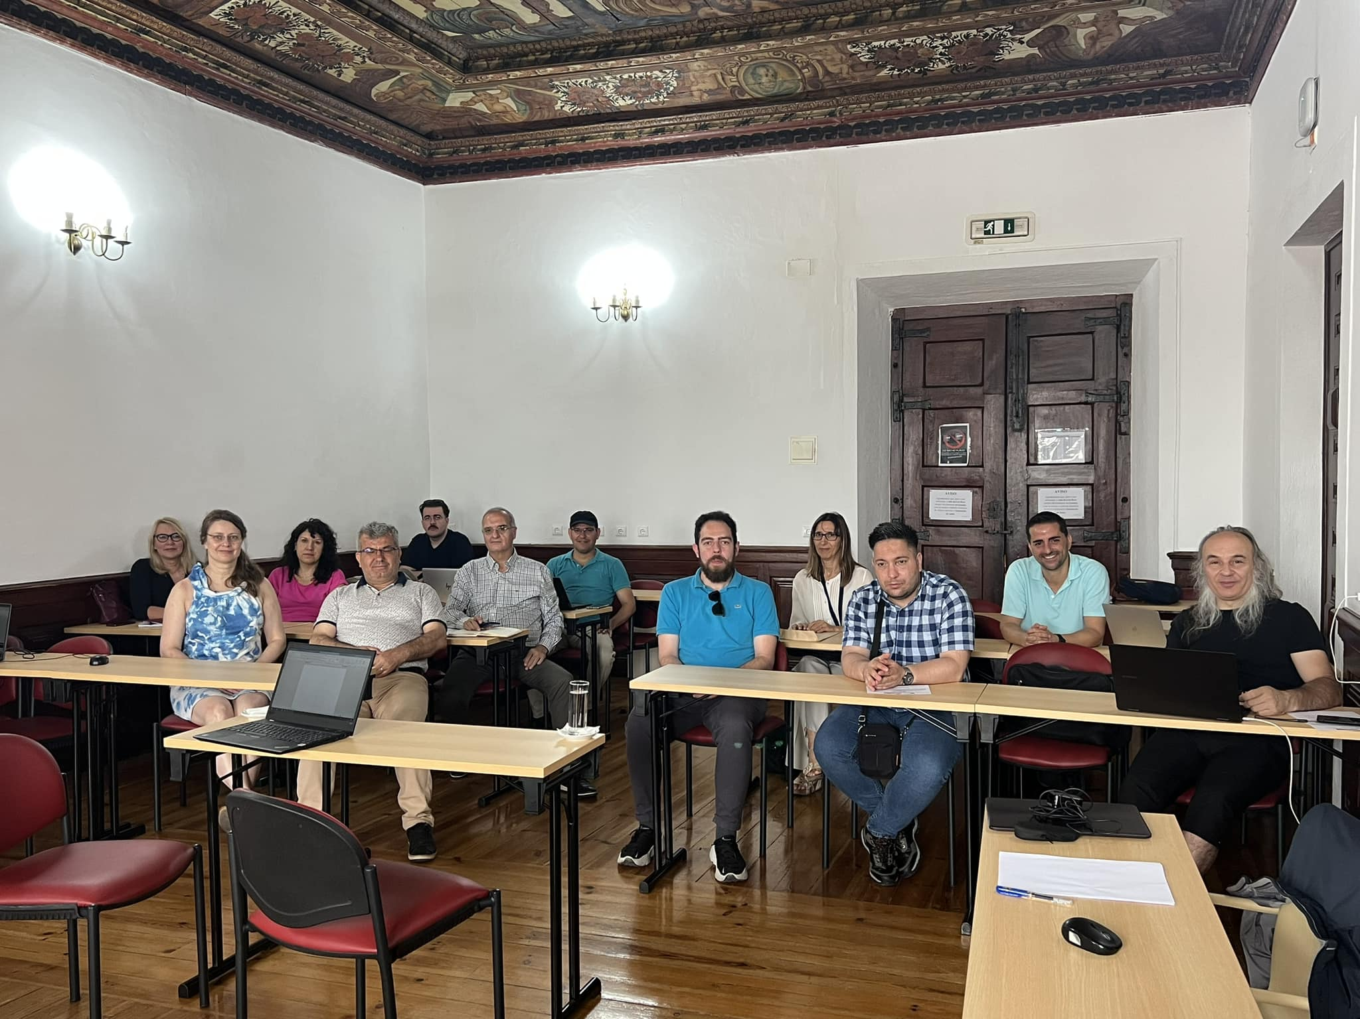

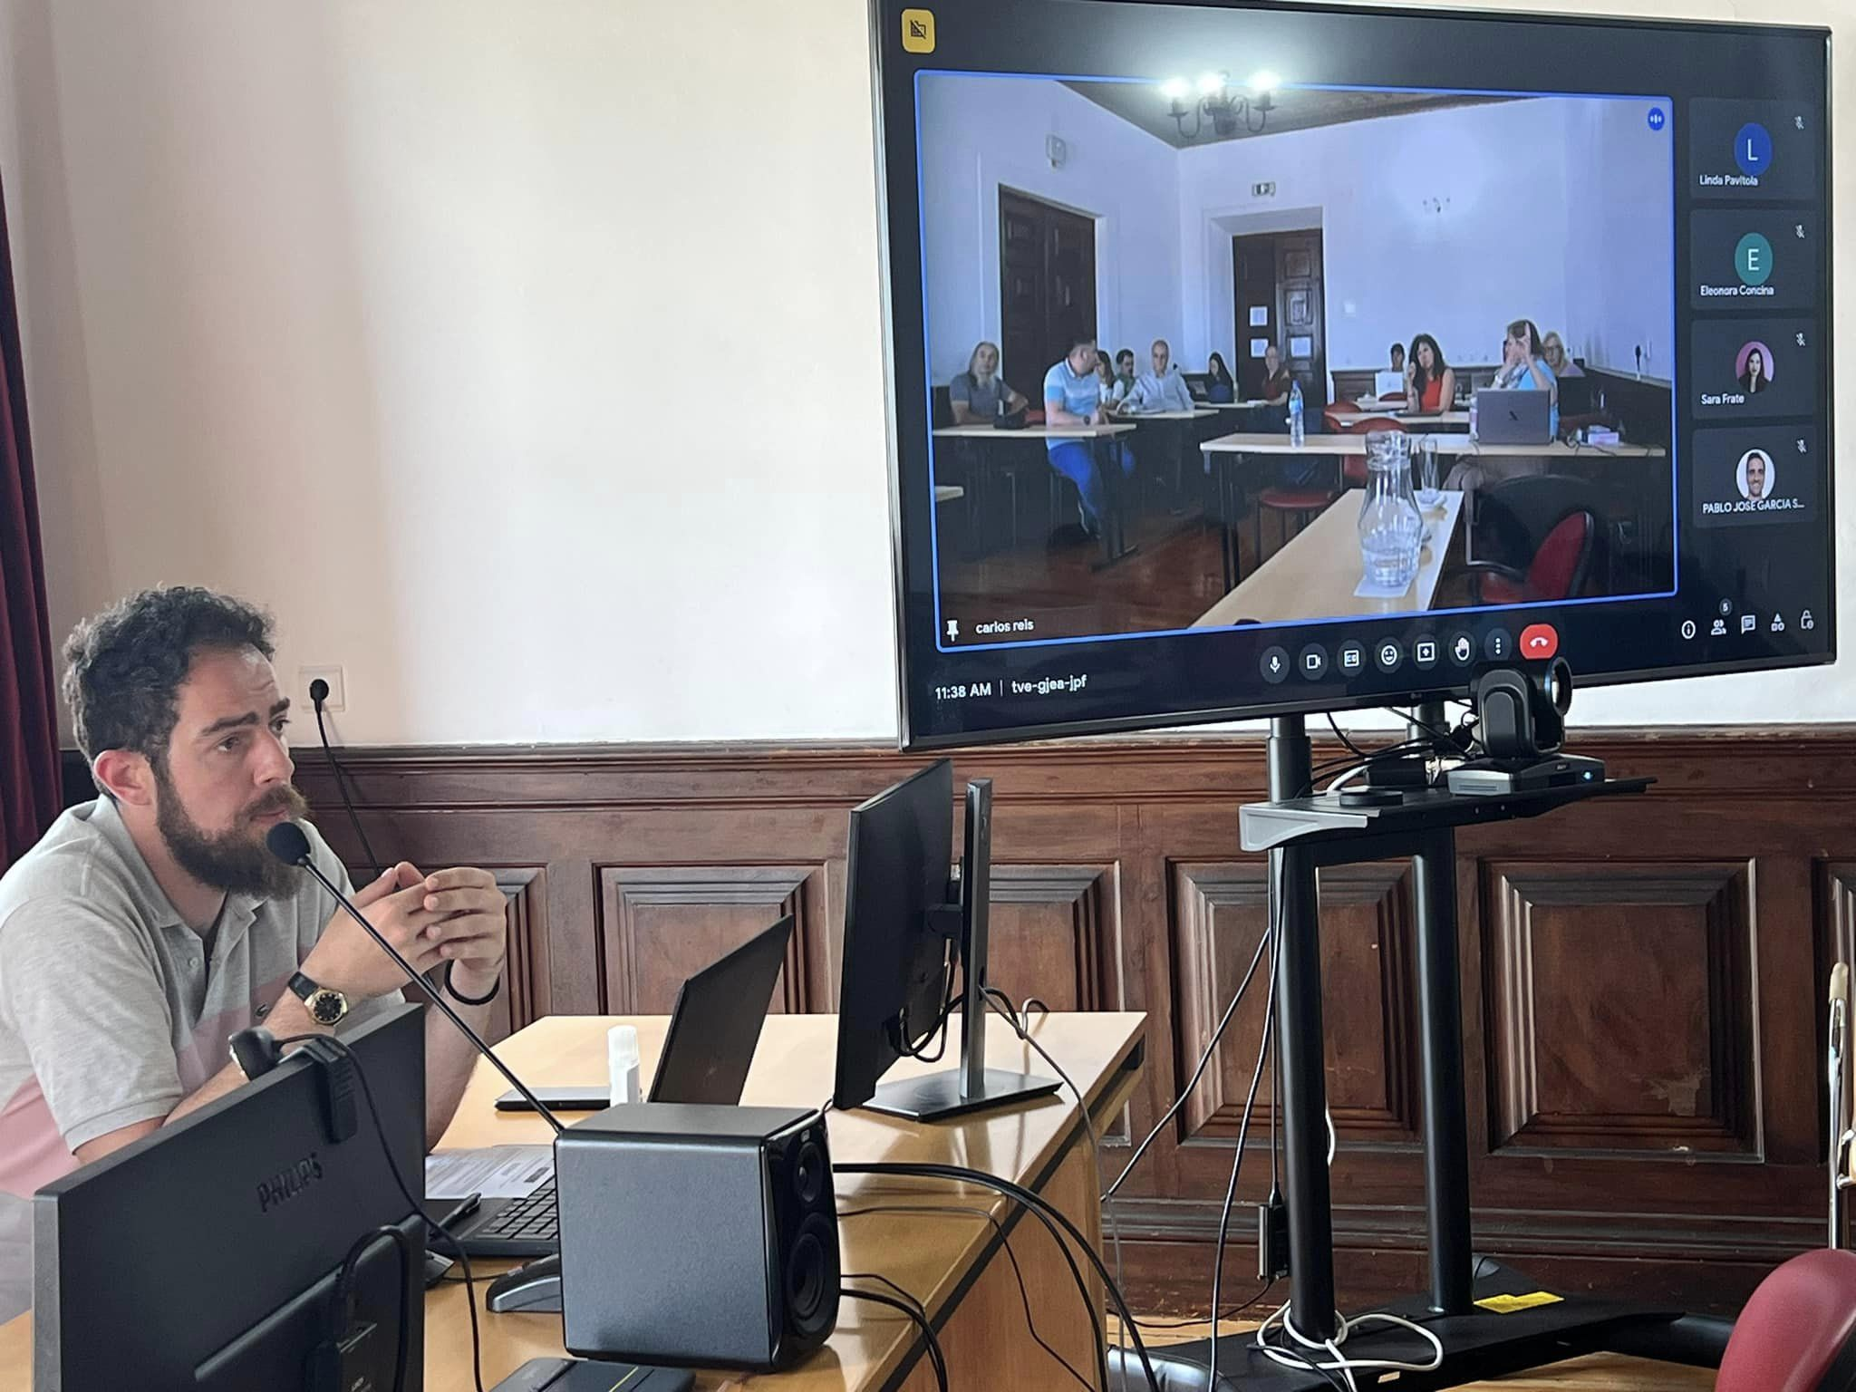

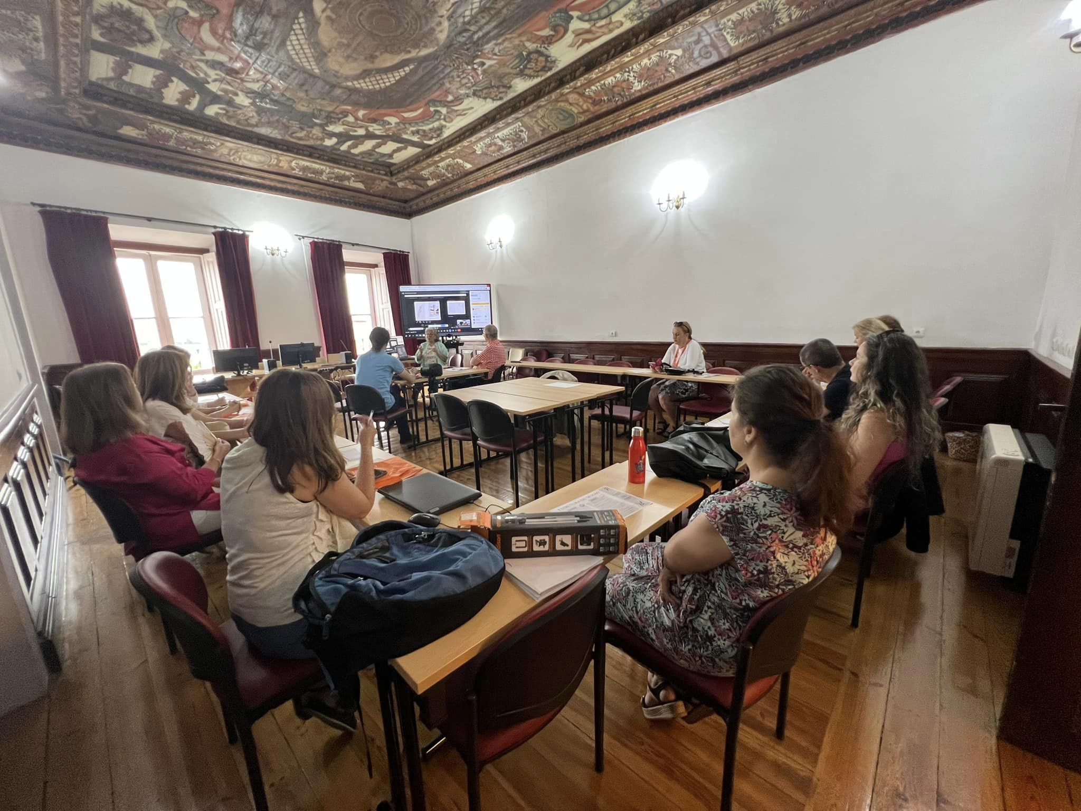

MEETING DETAILS
EU Beyond the Limits Ka 203 Meetings and Multiplier Event (ICLEL 2023) were held at the University of Coimbra. Prof. Dr. Osman TİTREK, from Sakarya University Faculty of Education is the coordinator of the project, and the 7-partner EU Ka 203 project "Beyond the Limits: Developing Entrepreneurship via Creativity in Schools (Project No: 2020-1-TR01-KA203-093989) project meetings and the 2nd Dissemination Activity-Multiplier Event (ICLEL 2023) events were successfully held at the Faculty of Psychology and Education of Coimbra University in Portugal between 2-8 July 2023. On July 2-5, 2023, International Project Meetings were held with the participation of at least 1 (one) participant from all partners in person or virtually. In these meetings, the project operation, the Needs Analysis application, the development of the e-book sections, and in the last meeting, the status of the outputs related to the program development studies and more effective implementation options were discussed. On July 6-8, 2023, ICLEL 2023 conferences, which is the Multiplier Event of the project, were successfully held in cooperation with the partners through the Hybrid method (face-to-face presentation, poster and virtual presentations).
Welcoming
02 JULY 2023.
All partners started to reach to the Coimbra and they settled to the hotels. After then about 4:00 pm we met to the University of Coimbra, Physchology and Education Faculty and we visited to the places we will conduct Project meetings. After then We had a discussion about the Project and results and we went to the dinner together.
03 JULY 2023
On the first day of the meeting, Prof. Dr. Carlos Sousa Reis welcomed everyone. He wished everyone well for their journey and the meeting. Everyone arrived on time for the meeting. Only the Italian team and Prof.Dr. Linda Pavitola from Latvia were absent. They attended meetings as virtually. Team selected Dr. Dan Petrica from Romania team as managing technical issues in the auditorium, while we are discussing to the project issues. Then we went to the hall where the meeting would be held. Before the meeting, a three-day meeting plan was distributed to everyone and it was stated that the meeting would be held by adhering to this plan if possible. Then the meeting started with an opening speech.

Project Coordination – Curriculum Development
Prof. Dr. Carlos Sousa Reis gave a short speech and then called on Prof.Dr. Osman Titrek as the chair of the project to give an opening speech. Prof.Dr. Osman Titrek started his speech by thanking everyone for attending the meeting. He then summarized what has been done up to this meeting and what needs to be done from now on. In general, the IP trainings, the development of online video training materials, the teacher training sections have been completed in the project of entrepreneurship development through creativity skills development. The book chapters on creativity and entrepreneurship development have been written but the publishing of the book is still to be finalized. Also, the 5-week program was developed in the curriculum development section. This needs to be updated to 14-week program. The results of the Needs Analysis need to be reported and published. Also, the results of this study will be presented at the dissemination activity of the project (ICLEL 2023) conference as a dissemination activity. After this brief summary, Prof.Dr. Osman Titrek started the meeting by wishing that this meeting would be beneficial for everyone.
Prof.Dr. Osman Titrek gave the task of coordinating the meeting to Dan from Romania team. During the three days, Dan decided who would speak during the meeting and when the meeting would be adjourned. He managed the process well. He did not allow any discussion or interpersonal dialog. Occasionally, when the meeting went off topic or participants were distracted, he called a break to allow the process to recover and resume. Prof. Dr. Dan handled the process in a smooth manner.
The Curriculum Development task was given to the Italian group. Italian group developed a 5-week program on creativity and entrepreneurship at university level. Before the meeting, they also prepared a 5-week high school part of the same program and sent it to the other groups via email. The template of the program they developed was prepared in accordance with the criteria set by the European Union. However, it does not meet the criteria set in the project in terms of both content and scope. The first day of the meeting was specifically dedicated to curriculum development. Sara and Michele, who attended the meeting online, insistently argued that the 5-week program was sufficient. However, Regina, whose specialty is entrepreneurship, stated that the program was too superficial and inadequate and that she would not allow her name to be attached to such a program. Prof.Dr. Osman Titrek, as he had stated in previous meetings, said that this program was inadequate. He also said that this program should have been prepared once for 14 weeks. As an alternative to this program, Prof.Dr. Osman Titrek sent an example of a separate 14-week program to all groups, using the template prepared by the Italian team. He told the Italian group that they could use this as an example and develop their own program. There was a long discussion about program development. As a result, the Italian team was given 2 weeks additional time. They were asked to update and resubmit their program in line with the feedback given during the meeting and the sample program. The first day's meeting generally went like this. Prof.Dr. Michele Biasutti and Sara Frate from Padova University said that they will follow them and create and share new developed programs at High school and University level.

Project Coordination – Joint Report
Prof.Dr. Osman Titrek also gave information about the joint report on the first day. Prof.Dr. Osman Titrek said that at the end of the project, the report will be submitted to the European Commission detailing what has been done during the project. He said that each group will write a report on what they have done during the project and send it to Prof.Dr. Osman Titrek, who will bring these reports together and prepare a general report. This joint report has to be submitted to the European Union Agency in order to finalize the project. Prof.Dr. Osman Titrek stated that this is how they will finalize the project. He politely asked each group to prepare their reports on this.
The meeting ended in this way on the first day.

04 JULY 2023
Project Coordination – E-Book Publication
On the second day of the project meeting the main agenda was the publication process of the book on Creativity and Entrepreneurship and which publishing house to publish it. Prof.Dr. David Rae, who was responsible leader for this, coordinated the process. Prof. Dr. David Rae explained the content and chapters of the book through a presentation. He said that the book is ready for publication, it has been reviewed twice by referees and each chapter has been edited. Finally, Regina reread it from cover to cover and gave feedback. In general, he said, the book chapters have all the prerequisites of a good publishing organization and are ready for publication. As a publishing organization, it was discussed that it could be published in the publishing organization of Granada University in Spain, which was suggested by Assoc. Prof.Dr. Pablo Garcia Sempere. For this, Dr. Sempere said that the printing costs of 3000 to 4000 Euros should be covered. This issue of printing costs was the main topic of discussion in today's meeting. There was no such money in the project and it had to be covered either from the PMI budget or from the Technician Fee. When Prof.Dr. Osman Titrek emailed the European Agency about this, the European Agency said that the Technician Fee (4275 Euro) cannot be used directly for book publishing in this way. On the second day of the meeting, it was discussed how the Technician Fee or PMI budget could be used for book publishing during the day. This issue was not fully resolved. Alternative solutions were produced. One of them is publishing the book at Coimbra University or another university. Or negotiating with another book publishing house. Another option was to publish the book electronically as an e-book. Prof. Dr. David Rae insisted that it would be better to publish the book there, especially since the publishing house of Granada University is a prestigious publishing house in the field. As a result, it was decided that Prof.Dr. Osman Titrek would contact the EU Agency to find out what money from the project could be used for the publishing costs and then decide on the publishing house. If there is enough money from the project, it is planned to publish the book in a good publishing house.

Coordination of presentations on the Entrepreneurship and Creativity Needs Analyses
The general topic of the afternoon session of the project meeting was how to use the results of the Need Analysis. Prof. Dr. Carlos Sousa Reis and Albertina led the session on this topic. Prof. Dr. Carlos Sousa Reis said that everything that needs to be done in the project regarding the need analysis has been done. He stated that the last update was done in May and the results were sent to everyone. Osman asked if we can publish these results in an SSCI indexed journal in line with these results. Albertina answered this question. She stated that the results of each country are meaningful but there are some problems in comparing and interpreting them. She said that some countries have insufficient data and that the statistical tests used in some countries are nonparametric or parametric. It is possible to reinterpret these results for the article, but we did what was necessary for the project. We will present these results at the ICLEL conference and publish them in the ICLEL Conference Book and we will have completed our task in terms of the project. At this point Prof. Dr. Carlos Sousa Reis intervened and said that if anyone wants to continue from here, they can take the work and turn it into a paper. There is also a parallel section of the ICLEL conference dedicated to presenting the need analysis results of this project. One person from each country participating in the project will present the need analysis results in the parallel section. These results will be also published in the booklet of the ICLEL conference and this issue will be closed within the scope of the project.
This concluded the second day of the meeting. Afterwards all group members visited the "Jardim Botânico and Seminário Maior".

05 JULY 2023
Project Coordination – E-Book Publication
On the third day of the meeting, the main agenda was again the publication of book chapters. Osman had asked the EU office if technician fees could be used to publish books and the answer was negative. Again, this issue was discussed within the group. As a result, the following three points were decided.
- The book will be published in publishing house in Spain if possible. For this, the EU office needs to show us the way to pay the publishing house.
- As an alternative way, publishing houses of universities can be used. The groups are not in favor of this. They think that there is a lot of work and effort involved in the book process and they would like the book to be published by a good publishing house if possible.
- As a final solution: the ISBN number will be taken and converted into an E-book and published on the project website as OPEN ACCESS
It was decided to implement one of these three ways for the e-book and book publication process

Visiting ICLEL2023 Rooms – Preparing the Multiplier Event
In this part of the meeting, the preparations for the ICLEL 2023 conference were finalized. The following preparations were made:
- Keynote speakers were determined in which order and on which topic they will speak
- Preparing the conference program and announcing it to the participants via e-mail
- Hanging flyers and posters
- Determining the gifts to be given
- Arranging lunch and cafe breaks
- Determining who will chair the conference sessions
- Coordination of virtual classrooms in the process of online presentations and determination of section chairs of virtual classrooms
- Preparation and signing of documents such as Transnational Meeting, Conference Organization Committee, Conference Participation Certificate
- Scanning and sending the flight tickets, passport entry and exit information of the participants of the meeting
- Electronic scanning and filing of conference attendance documents
- Organizing the gala dinner
After these preparations, the meeting ended. Before the end of the meeting, Osman thanked every member of the Transnational Project Meeting. Finally, he reminded them of the final things that came out of the meeting and the last things that needed to be done and ended the meeting. The next day the ICLEL 2023 conference was held.

Results
- We decided to ask there is a possiblity o use technician fee (E-Book technician fee: 4275 Euro) for e-book publication as open Access. We will continue e book publication process based on Eu Agency. If they give permission we will publish with Spanish Book company Octaedro Publishing. Leader Prof.Dr. David Rae has agreement for Octaedro to publish the E-Book entitled ‘Creative Learning for Entrepreneurship’ for the available project budget [negotiated by Pablo] of Euros 4275.

- We decided to ask there is a possiblity to use technician fee (E-Book technician fee: 4275 Euro) to publish Dissemination activity book with Springer Nature (Atlantis Press) . Atlantis Press will publish them as Open Access and will submit to the Web of Science Conference Citation Index for indexing.

- At the end of July, Padova University team will complete Curriculum Developments (High School and University Level) as 14 weeks + Final Exam program.

